**MPP Midterm Practice Problems**

1. What happens when the program is compiled/run?  
   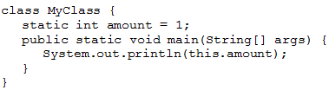
2. Compiler error
3. Runtime error
4. Outputs 1 to the console
5. Outputs 0 to the console
6. What happens when the program is compiled/run?  
   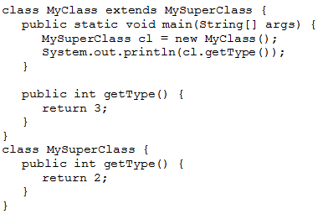
7. Compiler error
8. Runtime error
9. Outputs 2 to the console
10. Outputs 3 to the console
11. What happens when the following program is run?

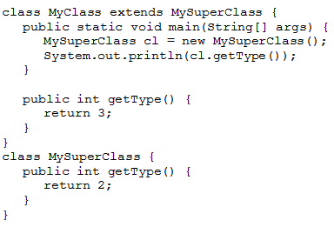

1. Compiler error
2. Runtime error
3. Outputs 2 to the console
4. Outputs 3 to the console
5. What happens when the following program is run?

public class Sub extends Super {

public static void main(String[] args) {

Sub.print();

}

}

public class Super {

static void print() {

System.out.println("hello");

}

}

1. Compiler error
2. Runtime error
3. Outputs “hello” to the console
4. What happens when the following program is run?

public class Sub extends Super {

public static void main(String[] args) {

Super s = new Sub();

s.print();

}

public static void print() {

System.out.println("bye");

}

}

public class Super {

static void print() {

System.out.println("hello");

}

}

1. Compiler error
2. Runtime error
3. Outputs “hello” to the console
4. Outputs “bye” to the console